Homework: Dow Jones

Due: 6 plots and 2 question answers

# Section 5: Plot from the Lattice Dot Plot

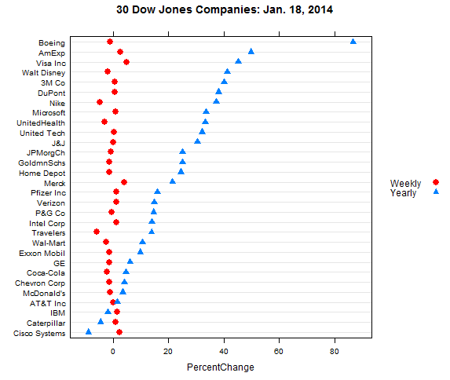

# Section 6: The refined ggplot()

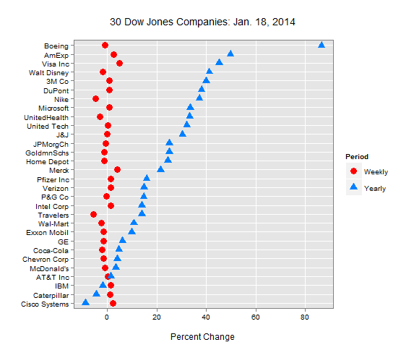

# Section 7: The two plots

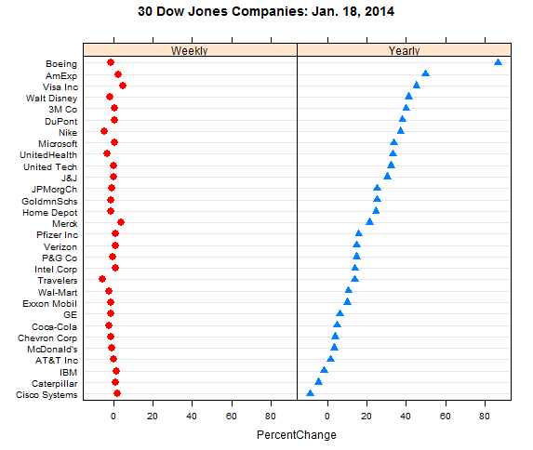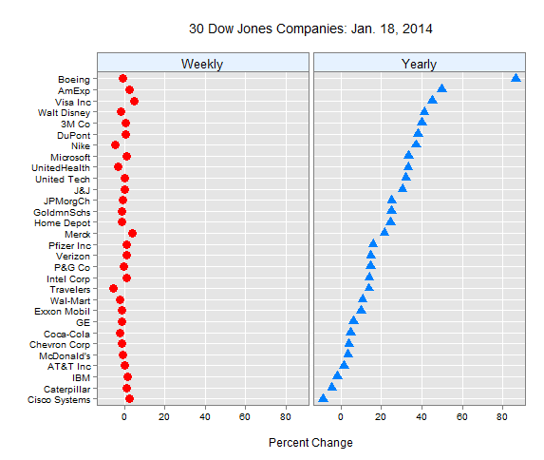

# Section 7: Produce two more plots using the older data in the DowJones2012Jan28.csv.

* Change the date in the labels
* Change the symbol colors in the plots
  + Change the RGB(1,0, 0) to “orange” and rgb(0, 0.5, 1) to “blue”.
  + Make the orange symbols smaller

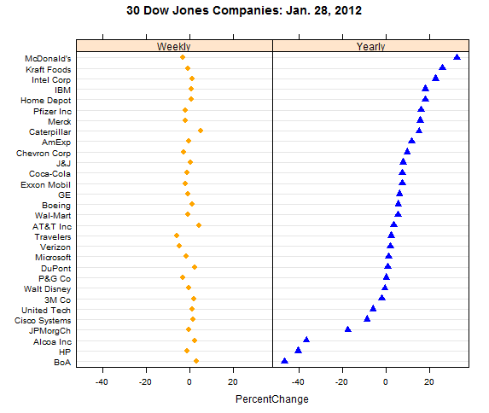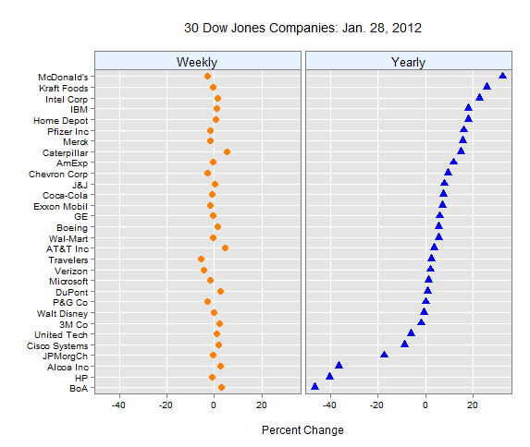

# Questions

## Do you prefer the black or gray text in ggplot?

I prefer the gray text to the black text in ggplot. I think that the gray text is a less intense and easier on the eyes.

## What is a reasonable specification for orange in terms or RGB intensities on a 0 to 1 scale?

A reasonable specification for orange in terms of RGB would be (1, 0.5, 0) on the 0 to 1 scale.

Homework: Singer Dot and Distribution Plots

Due 6 plots for 6 points

Section and plot 8 points:

# Section 2: Histogram Plot

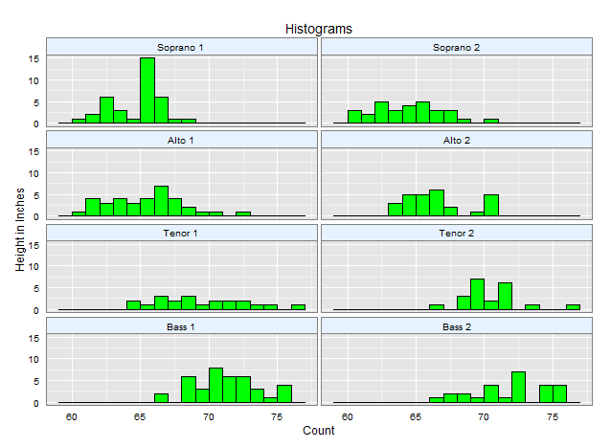

# Section 3: Row Labeled Box Plots

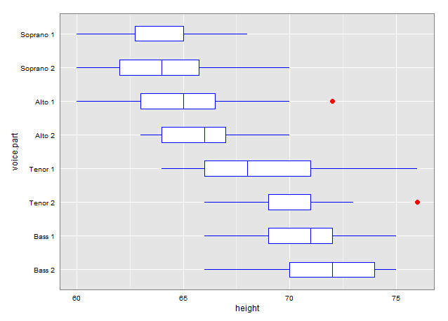

# Section 4.2: The Facet_Wrap Quantile Plot

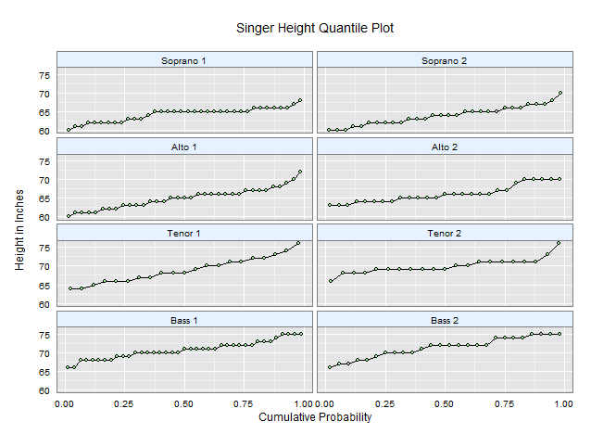

# Section 5.1: Q-Q Plot Soprano vs. Bass 2

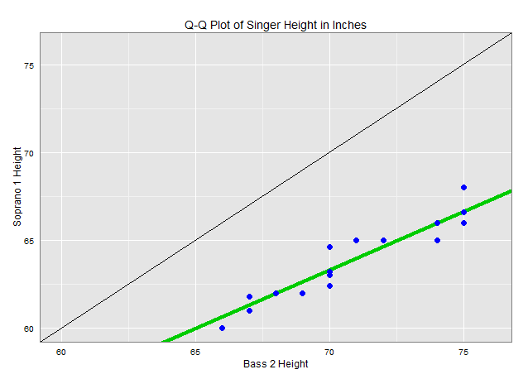

# Section 5.2: MD Plot: Mean and Difference Plot

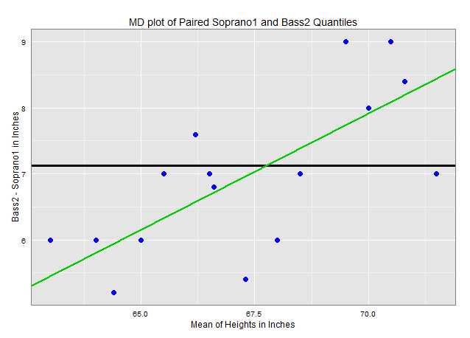

# Section 5.3: Q-Q Soprano 1 Residuals vs. Pooled Residuals

